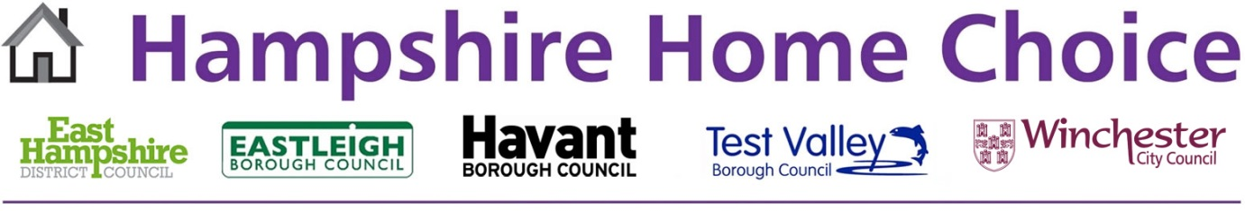

Property Symbols Used in the Adverts

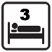 | Bedrooms: the number of bedrooms in this property
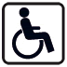 | Adapted: the property is suitable for people with a mobility or adapted need
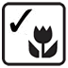 | Own Garden: this property has its own garden
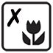 | No Garden: this property does not have its own garden
 | Off Road Parking: this property has off road parking
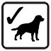 | Pets: pets are allowed in this property
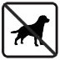 | No Pets: pets are not allowed in this property
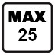 | Maximum Age: this property is only available to people of the age shown and below
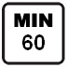 | Minimum Age: at least one household member must be the age shown
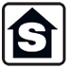 | Sheltered: this is a sheltered property
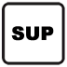 | Supported: this is a supported housing scheme
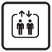 | Lift: there is a lift in this property
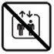 | No Lift: there is no lift in this property
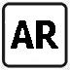 | Affordable Rent: this is an affordable rented property
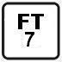 | Fixed Term Tenancy: this property has a fixed term tenancy (the number represents the number of years)
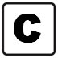 | Cross Boundary: this property is available for cross boundary moves

