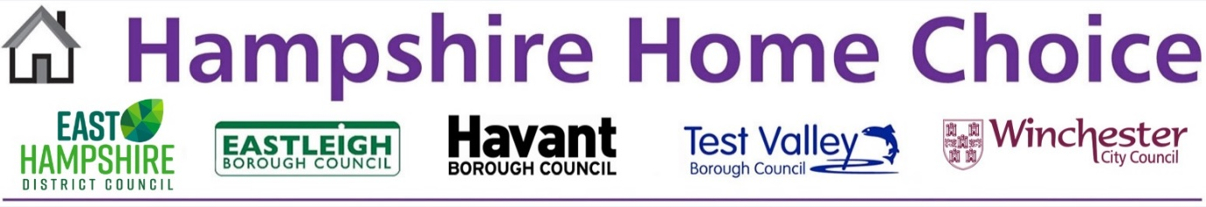
Hampshire Home Choice
Participating Landlords
The information the Councils holds about you may be shared with the following third parties:

A2 Dominion Group
Ability
Abri
Anchor Hanover
Aster Group
BluePine Living
Clarion
eastbrooke homes
Eastleigh Borough Council
English Rural
Enham Trust
Grainger Trust
Grayshott and District Housing Association
Hastoe Housing Association
Home Group
Housing 21
Hyde
Legal & General Affordable Homes (Managing Agent - Pinnacle Group)
Park Properties Housing Association (Managing Agent - Pinnacle Group)
PHA Homes
Places for People
Portsmouth City Council
Rentplus
Sage Homes
Sanctuary
Saxon Weald
Southern Housing
Sovereign Network Group
Stonewater
The Guinness Partnership
VIVID
Wickham Community Land Trust
Winchester City Council
Winchester Housing Trust

30 September 2025

