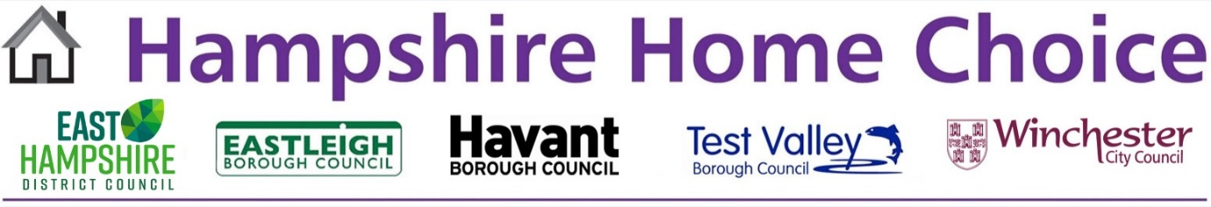
Hampshire Home Choice
Participating Landlords
The information the Councils holds about you may be shared with the following third
parties.
A2 Dominion
Ability
Abri
Anchor Hanover
Aster Group
Clarion
English Rural
Enham Trust
Grainger Trust (Managing Agent is Strutt & Parker)
Grayshott and District Housing Association
Home Group
Housing 21
Hyde
Legal & General Affordable Homes
PHA Homes
Places for People
Sage
Sanctuary Housing
Saxon Weald
Silva Homes
Southern Housing
Sovereign
Stonewater
The Guinness Partnership
VIVID
Wickham Community Land Trust
Winchester City Council
Winchester Housing Trust

17 March 2023

