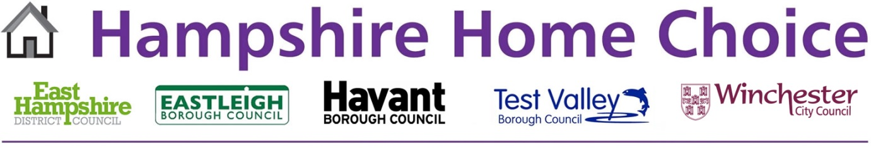

Figure 1 Hampshire Home Choice logo

**Hampshire Home Choice**

**Annual Report**

**2021**



Figure 2 Map of Hampshire Home Choice Sub-Region

THIS PLOT IS REPRODUCED FROM ORDNANCE SURVEY MATERIA WITH THE PERMNISSION OF THE ORDNANCE SURVEY ON BEHALF OF THE CONTROLLER OF HER MAJESTY’S STATIONARY OFFICE © CROWN COPYRIGHT. UNAUTHORISED REPRODUCTION INFRINGES CROWN COPYRIGHT AND MAY LEAD TO PROSECUTION OR CIVIL PROCEEDINGS. TEST VALLEY BOROUGH COUNCIL LICENCE NO. 100024295 2013

6 August 2021

**Contents**

**Introduction…………………………………………………………………………………3**

Background…………………………………………………………………………………..3

How the Scheme Operates…………………………………………………………………3

Qualification Criteria………………………………………………………………………3-4

Assessment of Bids…………………………………………………………………………4

**Other Information…………………………………………………………………………..4**

Rent in Advance……………………………………………………………………………..4

Notice Periods……………………………………………………………………………….4

Local Lettings Policies……………………………………………………………………...4

Section 106 Agreement………………………………………………………………….....4

**Housing Register………………………………………………………………………..5-8**

Suspended Applications……………………………………………………………………9

Debts owing to a Council or Registered Provider……………………………………….9

**Lettings…………………………………………………………………………………10-12**

**Refusals…………………………………………………………………………………….13**

**Average Waiting Times……………………………………………………………….14-16**

**Housing Development………………………………………………………………..17-29**

East Hampshire District Council………………………………………………………17-19

Eastleigh Borough Council…………………………………………………………….20-22

Havant Borough Council……………………………………………………………….23-26

Test Valley Borough Council…………………………………………………………..27-29

Winchester City Council………………………………………………………………..30-32

**Hampshire Home Choice Annual Report 2021**

**Introduction**

The purpose of this Report is to summarise the main outcomes over the last year from the Hampshire Home Choice (HHC) scheme. East Hampshire District Council, Eastleigh Borough Council, Havant Borough Council, Test Valley Borough Council and Winchester City Council, have agreed a common approach for the allocation of social housing across the five local authority areas and together operate a sub-regional choice based lettings scheme called Hampshire Home Choice.

**Background**

HHC was launched in April 2009 and originally managed by East Hampshire District Council, Havant Borough Council and Winchester City Council. Test Valley Borough Council joined the partnership in June 2011, and Eastleigh Borough Council joined in February 2014. In 2012 a Manager was appointed and is employed by Test Valley Borough Council on behalf of the partnership.

**How the Scheme Operates**

The Councils participating in HHC advertise social housing vacancies using the same system that operates as follows:

* The Councils use a single IT system and website for registering applicants and advertising and allocating properties.
* Available social housing across the 5 Council areas is advertised on the HHC website every week.
* Applicants who have been accepted onto the Housing Register can bid for up to 3 properties they are interested in each week, either online or by phone.
* All of the vacancies advertised through the scheme are owned by Winchester City Council or Registered Providers (RP’s).
* The Councils operate the same HHC Allocations Framework.
* The HHC Allocations Framework is a jointly agreed policy. Along with the HHC Operational Procedures detail all aspects of the allocation/nominations process, including the responsibility for decisions, policy on offering choice to applicants, how applications will be assessed, processed and how decisions will be made.
* Each Council will continue to maintain its own local authority Scheme of Allocations which may contain separate policies to address and reflect local priorities.

**Qualification Criteria**

A person will normally qualify to join the HHC Register and therefore qualify for an allocation under the HHC Scheme, if they are:

* In Housing Need and
* Have a single or joint household income of less than £60,000 per annum or £45,000 for Eastleigh applicants and/or
* Assets and/or savings of less than £16,000, and
* Have a local connection with one of the participating Councils through residency, family connections or employment.

Persons with no housing need or local connection will not normally qualify to be registered on HHC.

**Assessment of Bids**

Available properties are advertised on the HHC website from 00:01 on a Wednesday to 23:59 on a Sunday. The principle of the system is that properties are normally offered to the applicant with the highest priority and who meets all of the advert and preference criteria. Priority within the band is determined by the date the application was awarded that band. The letting of the property will be organised by the RP or Winchester City Council Landlord Services.

The HHC website address is [www.hampshirehomechoice.org.uk](http://www.hampshirehomechoice.org.uk/)

**Other Information**

**Rent in Advance**

Most partner landlords in HHC require new tenants to provide rent in advance before they move into their new home. Further details of which partner landlords require rent in advance can be found on the HHC website.

**Notice Periods**

Some applicants may have to give notice to end their tenancy properly before accepting an offer of a new property through HHC. Applicants should seek advice from the Housing Service or Citizens Advice Bureau if they are unsure about the notice they are required to give.

**Local Lettings Policies**

Local Lettings Policies will be used to ensure, where possible, that there is a mixed and balanced community. Local Lettings Policies for some existing properties and initial lettings on new-build schemes may specify different priorities for allocating properties. Properties subject to such a policy will be clearly labelled in the property advert.

Local Lettings Policies may be applied in addition to any local planning restrictions (contained in agreements made under Section 106 of the Town and Country Planning Act 1990) which may in place, but will not override them. These Local Lettings Policies will be agreed by the respective RP and local authority Housing Manager.

**Section 106 Agreement**

A Section 106 Agreement is the legal framework which sets out, among other developer contributions, the terms and conditions for the provision of affordable housing. This agreement is part of the planning requirement that the Local Authority will have with the land owner. In some instances the Agreement will determine who is eligible for the properties to be let.

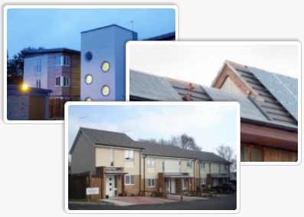

Figure 3 Photo of 3 development images

**Housing Register**

As of the 1 April 2021 a total of 8,542 households were registered on Hampshire Home Choice. 2,200 households are registered with Test Valley, 1,905 with Eastleigh, 1,564 with Havant, 1,452 with Winchester and 1,421 with East Hampshire.

Compared with the figure of 8,207 recorded on the 1 April 2020, there has been an overall increase of 335 households registered on HHC.

Since the 1 April 2020, the number of households registered has increased for East Hampshire by 121, Test Valley by 89, Winchester by 83, Eastleigh by 66 and Havant by 24.

The following details the total number of households registered on HHC as of 1 April 2021 by:

Local authority area the applicant is registered with:

2,200 (26%) of households are registered with Test Valley, 1,905 (22%) with Eastleigh, 1,564 (18%) with Havant, 1,452 (17%) with Winchester and 1,421 (17%) with East Hampshire.

Local authority area the applicant is registered with and assessed band:

Of the 8,542 households registered on the Housing Register, 23 (0.3%) are in band 1, 1,012 (12%) in band 2, 7,047 (82%) in band 3 and 460 (6%) in band 4.

Local authority area the applicant is registered with and assessed bedroom need:

Of the 8,542 households registered on the Housing Register, 4,616 (54%) have a 1 bed assessed need, 2,315 (27%) have a 2 bed assessed need, 1,252 (15%) have a 3 bed assessed need and 359 (4%) have a 4+ bed assessed need.

Local authority area the applicant is registered with and application type:

Of the 8,542 households on the Housing Register, 1,773 (21%) are Transfer applications. A Transfer Application means an applicant is an existing social housing tenant who has been assessed as having a need to move, whilst General Register application is applied to all other applications.

Ethnicity:

7,546 (88%) applicants registered on Hampshire Home Choice have stated on their application form they are White British.

420 (5%) applicants registered on Hampshire Home Choice have stated on their application form they are White Any Other.

576 (7%) applicants registered on Hampshire Home Choice have stated on their application form they are; Any other Mixed/multiple ethnic background, Asian, Asian Any Other, Asian Bangladeshi, Asian British, Asian Chinese, Asian Indian, Asian Pakistani, Black, Black African, Black Any Other, Black British, Black Caribbean, Gypsy or Irish Traveller, Mixed W & B African, Mixed W & B Asian, Mixed W & B Caribbean, Other Ethnic Group, Romany Gypsy or White Irish.

73 applicants registered on Hampshire Home Choice have stated on their application form they Prefer not to say what their ethnic origin is.

**Suspended Applications**

There are usually a number of applications suspended at any one time due to the Councils waiting for information which is required to assess an application.

HHC also operates a Suspension Policy and applications may be suspended in the following circumstances; where an applicant has deliberately worsened their circumstances or where there is unacceptable behaviour or where a debt is owed to a local authority or registered housing provider or where an applicant refuses 2 suitable offers of accommodation within a 6 month period.

Suspended applications by local authority area and suspended reason:

The number of applications suspended due to awaiting information is 1,472, whilst 334 applications are suspended due to outstanding debts, refusing 2 offers within 6 months or unacceptable behaviour.

**Debts owing to a Council or Registered Provider**

Where an applicant and/or their partner owe money to a local authority or registered provider and there is no payment arrangement in place which has been adhered to for a period of 6 months, their application may be suspended.

Examples of money owed include:

* Current rent arrears and/or
* Former tenant rent arrears and/or
* Repair costs/Rechargeable works orders and/or
* Claim against deposit scheme for damage or rent arrears and/or
* Rent in advance and or deposit scheme costs owing and/or
* Outstanding debt with a private landlord may be considered.

**Lettings**

The following details the number of lettings between 1 April 2020 and 31 March 2021 by:

Local authority area:

Of the 2,081 lettings there were 591 (28%) in Winchester, 565 (27%) in Test Valley, 396 (19%) in Eastleigh, 322 (16%) in East Hampshire and 207 (10%) in Havant.

Local authority area and property size:

Of the 2,081 lettings, 794 (38%) were to 0/1 beds, 918 (44%) to 2 beds, 318 (15%) to 3 beds and 51 (3%) to 4+ beds.

Local authority area and assessed band:

Of the 2,081 lettings, 35 (2%) were made to applicants in band 1, 691 (33%) to applicants in band 2, 1,323 (64%) to applicants in band 3 and 32 (1%) to applicants in band 4.

Local authority area and application type:

Overall, 525 (25%) of lettings were made to transfer applicants. 30% of lettings in Winchester were made to transfer applicants, compared with 28% in East Hampshire, 27% in Test Valley, 19% in Eastleigh and 14% in Havant. A Transfer Application means an applicant is an existing social housing tenant and has been assessed as having a need to move, whilst General Application is applied to all other applications.

Ethnicity:

1,863 (90%) properties were let to applicants who stated on their application form they are White British.

102 (5%) properties were let to applicants who stated on their application form they are White Any Other.

116 (5%) properties were let to applicants who stated on their application form they are; Any other Mixed/multiple ethnic background, Asian, Asian Any Other, Asian Bangladeshi, Asian British, Asian Chinese, Asian Indian, Asian Pakistani, Black, Black African, Black Any Other, Black British, Black Caribbean, Gypsy or Irish Traveller, Mixed W & B African, Mixed W & B Asian, Mixed W & B Caribbean, Other Ethnic Group, Romany Gypsy or White Irish.

9 properties were let to applicants who stated on their application form they would Prefer not to say what their ethnic origin is.

**Refusals**

A refusal is where an applicant refuses an offer of a property they have bid on or where a Landlord refuses to accept an applicant (the nominee) for a property.

The issue with refusals is that they impact on the timescales a property is empty (known as void times), which incurs rent loss for landlords. It is important that applicants only bid for suitable properties that they are genuinely interested in.

Anyone who successfully bids and is offered suitable accommodation, but subsequently refuses an offer of a property on two occasions within a six month period, will not be able to bid for further properties for six months from the date of the second refusal, as their application will be suspended.

Refusals by local authority area and refusal type:

Between 1 April 2020 and 31 March 2021, a total of 2,873 offers were made for 2,081 properties. Of these, **792** offers were refused, a 28% refusal rate.

**East Hampshire** - a total of 437 offers were made for 322 properties. Of these, 115 offers were refused, a 26% refusal rate.

**Eastleigh** - a total of 596 offers were made for 396 properties. Of these, 200offers were refused, a 34% refusal rate.

**Havant** - a total of 273 offers were made for 207 properties. Of these, 66 offers were refused, a 24% refusal rate.

**Test Valley** - a total of 742 offers were made for 565 properties. Of these, 177offers were refused, a 24% refusal rate.

**Winchester** - a total of 825 offers were made for 591 properties. Of these, 234 offers were refused, a 28% refusal rate.

The overall refusal rate is 28%. Eastleigh has seen the highest refusal rate of 34% whilst Havant and Test Valley have seen the lowest refusal rate of 24%.

**Average Waiting Times**

The following details the average waiting times for applicants housed between 1 April 2020 and 31 March 2021 by local authority area.

These figures do not include properties advertised as requiring a local connection to a village/parish or properties subject to any other specific requirements.

The average waiting times are meant as an indication and do not mean an applicant will be housed within these timescales. It is likely that the waiting times will vary when calculated again in 12 months.

**East Hampshire:**

**Band 2**

1 bed – 10 months

2 bed flat – 11 months

2 bed house - 1 year 8 months

3 bed - 11 months

4+ bed - 1 year

Aged 55+ properties - 5 months

**Band 3**

1 bed – 2 years 3 months

2 bed flat – 1 year 5 months

2 bed house - 4 years

3 bed - 2 years 6 months

4+ bed - 2 years

Aged 55+ properties - 15 months

**Eastleigh:**

**Band 2**

1 bed – 1 Year

2 bed flat – 6 months

2 bed house - 1 year 3 months

3 bed - 1 year 5 months

4+ bed - 1 year 8 months

Aged 55+ properties - 1 year 4 months

**Band 3**

1 bed – 3 years 10 months

2 bed flat – 1 year 7 months

2 bed house - 3 years 1 month

3 bed - 3 years 6 months

4+ bed - 6 years 10 months

Aged 55+ properties - 2 years 1 month

**Havant:**

**Band 2**

Bedsit - 4 months

1 bed – 11 months

2 bed flat – 1 year 2 months

2 bed house - 1 year 6 months

3 bed – 1 year 11 months

4+ bed - 1 year 3 months

Aged 55+ properties - 6 months

**Band 3**

Bedsit – 2 years

1 bed – 4 years 2 months

2 bed flat – 3 years

2 bed house - 5 years

3 bed - 5 years 2 months

4+ bed - 7 years 6 months

Aged 55+ properties – 1 year 6 months

**Test Valley (Andover):**

**Band 2**

1 bed – 1 year 9 months

2 bed flat – 1 year

2 bed house - 2 years

3 bed – 2 years 9 months

4+ bed - 3 years 6 months

Aged 55+ properties – 1 year 1 month

**Band 3**

1 bed – 3 years 6 months

2 bed flat – 2 years 3 months

2 bed house - 5 years

3 bed - 4 years 1 month

4+ bed - 3 years 8 months

Aged 55+ properties – 2 years 1 month

**Test Valley (Romsey):**

**Band 2**

1 bed – 1 Year 7 months

2 bed flat – 1 year 6 months

2 bed house - 2 years 10 months

3 bed - 2 years 4 months

4+ bed - 6 years 1 month

Aged 55+ properties - 1 year 3 months

**Band 3**

1 bed – 3 years 3 months

2 bed flat – 1 year 7 months

2 bed house – insufficient data

3 bed - insufficient data

4+ bed - insufficient data

Aged 55+ properties - insufficient data

**Winchester:**

**Band 2**

1 bed – 1 year 2 months

2 bed flat – 8 months

2 bed house – 1 year 7 months

3 bed – 1 year 2 months

4+ bed - 10 months

Aged 55+ properties – 10 months

**Band 3**

1 bed – 3 years 7 months

2 bed flat – 1 year 7 months

2 bed house - 4 years 1 month

3 bed - 3 years 10 months

4+ bed - 1 year 3 months

Aged 55+ properties – 1 year 2 months

|  |  |
| --- | --- |
| **East Hampshire District Council**  **Housing Development** | Figure 4 East Hampshire District Council logo |

This year the Council helped support the delivery of 98 affordable homes. Due to the on-going coronavirus pandemic, the total number is down from what we had forecasted, however, completions began to increase again later in the year as work on site resumed.

It’s often difficult to find affordable housing for those in need of wheelchair accessible accommodation. Following a two year wait on Hampshire Home Choice, a three bedroom house was allocated to a family in Chawton. The development team alongside Private Sector Housing, Housing Options and the South Downs National Park have provided funding and support to enable the construction of a single storey side extension. This provides a separate entrance, a ground floor wet room and bedroom for a severely disabled child.

Please see a selection of photos of adapted property in Chawton below;

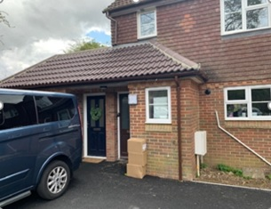

Figure 5 Adapted property in Chawton

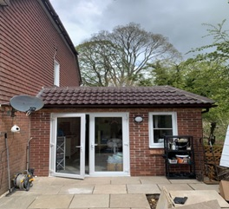

Figure 6 Adapted property in Chawton

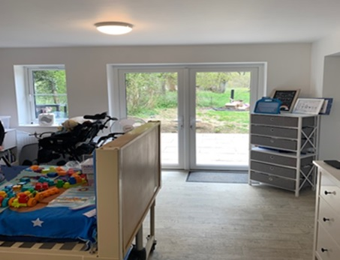

Figure 7 Adapted property in Chawton

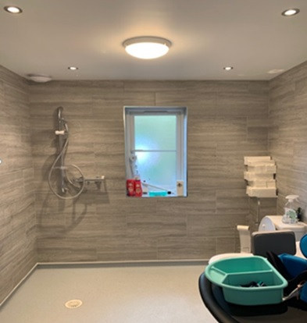

Figure 8 Adapted property in Chawton

We have set a target of delivering 150 affordable homes for 2021/22 and hope to continue to provide a range of affordable housing options with Housing Associations operating in our district.

**Selection of schemes constructed last year:**

Andlers Ash, Liss – Stonewater

This scheme is being delivered by Stonewater Housing Association. Stonewater are providing 32 affordable homes, with a mix of one, two and three bedroom properties.

Stonewater met the Councils planning policies, achieving 40% affordable housing on site, with a tenure mix of 70% affordable rent / 30% shared ownership.

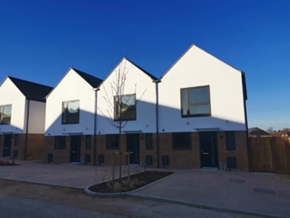

Figure 9 Andlers Ash, Liss

Downhouse Road, Horndean – Abri

This scheme is being delivered by Abri. Abri are providing a 100% affordable housing scheme consisting of 29 one, two and three bedroom properties for social rent and shared ownership.

Social rented housing is supported to ensure the homes are affordable for applicants registered on Hampshire Home Choice.

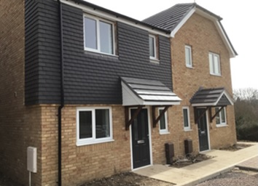

Figure 10 Downhouse Road, Horndean

|  |  |
| --- | --- |
| **Eastleigh Borough Council**  **Housing Development** | EBC Logo A4 Green  Figure 11 Eastleigh Borough Council logo |

Our Corporate Plan 2015 – 2025 identifies that we are seeking to ensure a sufficient supply of well-designed homes that can meet the diverse needs of residents now and in the future. This is underpinned by our strategy to work across our services, and with strategic partners, to deliver a housing programme thereby increasing supply for the community across all tenures.

Eastleigh Borough Council continues to strive to support the delivery of a continual supply of affordable homes to meet the needs of those on Hampshire Home Choice as well as those seeking low cost homeownership. Last year in conjunction with our partners 461 new homes for rent and low-cost homeownership were completed. This year there have been 271 new affordable homes with some delays owing to Covid meaning a reduction in anticipated completions. These included 132 for rent and 139 for shared ownership.

There are several larger developments in the Borough that are contributing to affordable housing provision some of which are already under development with homes completing and others are just starting on site. These larger sites together with the other developments in the pipeline will support the supply of new affordable housing throughout next year and beyond.

**Detailed below are a selection of schemes:**

Cranbury Gardens (Heron Walk), Bursledon - Aster

Taylor Wimpey are the developer for this site in Bursledon. In conjunction with Aster there will be a total of 16 homes for rent and shared ownership. The homes are all due to be completed by Spring 2021.

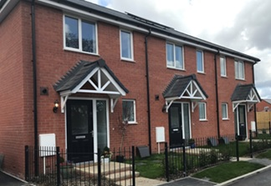

Figure 12 Cranbury Gardens, Bursledon

Kestral Park, Hamble Lane - VIVID

Taylor Wimpey in conjunction with VIVID are providing a total of 70 affordable homes for rent and shared ownership. The homes will be phased over the development with the final affordable homes due to be completed by spring/summer 2021.

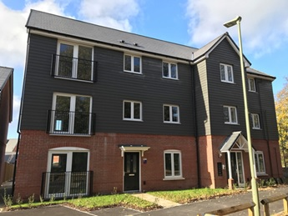

Figure 13 Kestral Park, Hamble Lane

St Swithun Wells Church and adjacent land, Allington Lane, Fair Oak - Sovereign

Linden Homes developed this site and in conjunction with housing provider Sovereign they provided a total of 25 affordable homes for rent and shared ownership. The final homes were completed summer 2020.

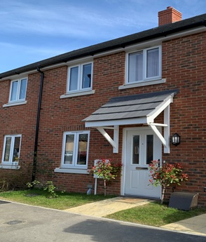

Figure 14 Allington Lane, Fair Oak

Pylands Lane, Bursledon - Abri

Bellway homes are the developer for this site and in conjunction with Abri (formerly Radian) they provided a total of 88 affordable homes for rent and shared ownership. The final affordable homes completed summer 2020.

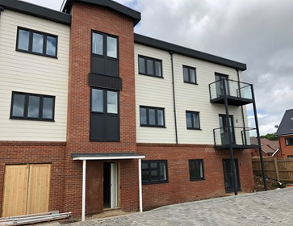

Figure 15 Pylands Lane, Bursledon

Hammerley Farm, Horton Heath - Abri

Foreman Homes are the developer for this site and in conjunction with Abri (formerly Radian) they are providing 37 affordable homes for rent and shared ownership on Phase one. The homes will be phased through to Summer 2021 with some already completed in Winter 2020.

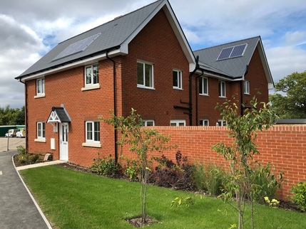

Figure 16 Hammerley Farm, Horton Heath

|  |  |
| --- | --- |
| **Havant Borough Council**  **Housing**  **Development** | Figure 17 Havant Borough Council logo |

According to latest housing register data, the combined total need for affordable homes is 2,532 dwellings within the Borough of Havant. There remains a significant need for affordable dwellings and increasing the supply of affordable housing within the district is a priority for Havant Borough Council.

Affordable housing is defined as in Annex 2 of the National Planning Policy Framework, and national policy requires major sites (10 dwellings or more) to make at least 10% of homes available for affordable home ownership; the councils preferred route to affordable home ownership is Shared Ownership.

Available Hampshire Home Choice, and Help to Buy South data, continues to suggest that the demand for affordable rented homes (Affordable Rent and Social Rent) still exceeds that of affordable home ownership products.

Following comprehensive affordability analysis, our Submission Havant Borough Local Plan has suggested that a 66% Affordable Rent, 33% Shared Ownership split is provided on all new developments of 10 or more units.

Despite the constraints of the COVID-19 pandemic, which caused severe delays in new home construction, Havant Borough Council’s Registered Provider partners have sustained delivery of affordable homes to meet the needs of those on our waiting lists.

Unfortunately, there was zero delivery in quarters one and two of 2020/21, however, a total of 58 new homes were completed in quarters three and four consisting of:

Affordable Rent 31

Shared Ownership 25

Social Rent 2

As in previous years the Waterlooville Major Development Area (MDA), the largest development in the Borough, continues to contribute to our affordable housing provision although the units now being developed are in the Winchester City Council area. Despite this the new affordable homes are available to both Havant and Winchester applicants alike due to the site’s proximity to the Havant area.

There are various other sites at different stages of development across the borough that will start to deliver their affordable homes over the next couple of years.

**Schemes currently under construction in Havant are:**

Brookvale - Aster

Currently reaching it last stages of development Brookvale, a Bellway site on land South of Bartons Road in Havant, will, once completed will deliver a total of 175 new homes within the borough. Of these 53 were negotiated as affordable and so far, 40 affordable units have already been handed over to Aster. The remaining 13 are expected up to November 2021.

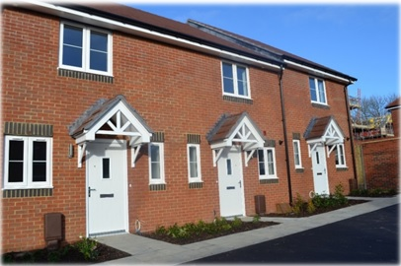

Figure 18 Brookvale, Havant

Saxon Corner, Emsworth - Sage

Saxon Corner, on land adjacent to Selangor Avenue in Emsworth is being developed by Barratts DWH. In total there will be 144 new homes on this site of which 44 (consisting of two and three bedrooms) will be affordable with an equal split of Affordable Rent and Shared Ownership. To date 14 units have been handed over to Sage Housing with another 20 expected throughout 2021/2022, then the final 10 units at the end of May 2022.

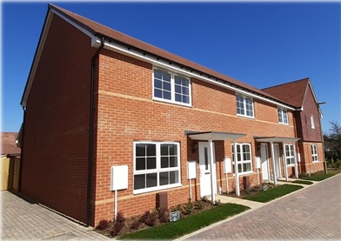

Figure 19 Saxon Corner, Emsworth

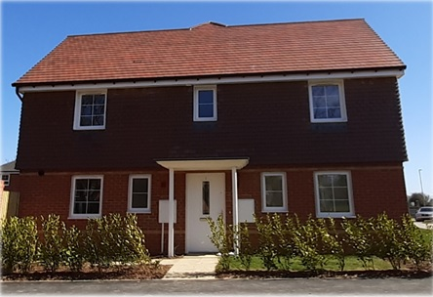

Figure 20 Saxon Corner, Emsworth

Catherington Park, Waterlooville - Aster

This new phase by Lindens is part of the Woodcroft Farm development that will once completed provide 288 new homes for Havant Borough. Phase two is currently under construction with Aster chosen as the RP to deliver 40 affordable homes consisting of 21 for Affordable Rent, and 19 for Shared Ownership.

13 homes have already been handed over with a further 21 expected between now and the end of October 2021. The remaining 6 units will be available from the end of April 2022.

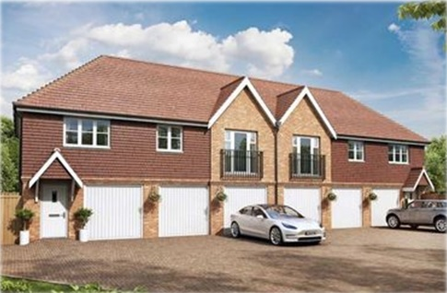

Figure 21 Catherington Park, Waterlooville

Woodcroft Copse – The Guinness Partnership

Woodcroft Copse, adjacent to Woodcroft Lane in Lovedean is a small site of 43 new affordable homes, comprising one, two, three and four bedrooms, being developed by The Guinness Partnership. Once complete there will be 18 Social Rent properties, and 25 units for Shared Ownership. To date five units have achieved completion, with seven more due in June 2021, 11 in June 2022, and a further 20 expected to be handed over in June 2023.

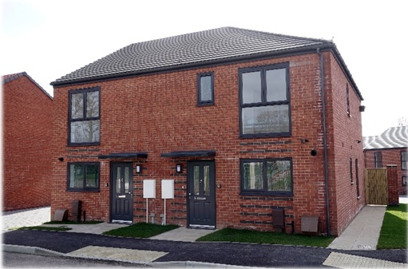

Figure 22 Woodcroft Copse, Lovedean

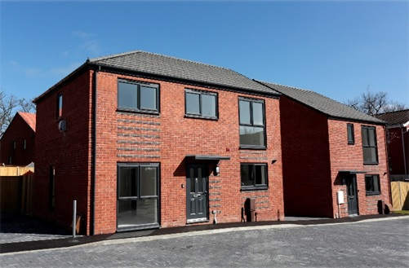

Figure 23 Woodcroft Copse, Lovedean

|  |  |
| --- | --- |
| **Test Valley Borough Council**  **Housing Development** | TVBC logo (RGB)  Figure 24 Test Valley Borough Council logo |

**The delivery of affordable homes is important in improving the quality of life for residents in the borough. The Council continue to make every effort to meet, and often exceed the annual target for the provision of 200 affordable homes.**

Affordable housing provides homes for people on lower incomes who are unable to meet their housing needs through the private housing market. In Test Valley the Housing Development Team work in partnership with primarily Affordable Housing Providers (also known as “Registered Providers” or “Housing Associations”), focusing on affordable/social rent and low cost homeownership housing (such as shared ownership). We also work closely with private housing developers and Parish Councils for rural affordable housing delivery.

2020 – 21 financial year has seen the delivery of a total of 296 affordable homes, considerably exceeding the target set of 200 dwellings. This figure incorporates both rented and shared ownership homes, as well as a small number of discount market units. Included in the 296 homes are 18 adapted homes for rent for people who use wheelchairs, or will need to use a wheelchair in the foreseeable future, thereby ensuring that new affordable homes meet the needs of all members of the community. In last year’s report we talked about our intention to deliver more **social** rented homes to assist with affordability for those on the lowest incomes, and we are pleased to report that 60 of the rented homes delivered in 2020-21 were let at a social rent, rather than an affordable rent.

New affordable homes are still being built across Test Valley and we look forward to providing new homes in the future, for local residents. All of these homes will be advertised on Hampshire Home Choice website**.** [Hampshire Home Choice](https://www.hampshirehomechoice.org.uk/) is a way of looking for social housing available for rent across the Hampshire Home Choice sub-region and aims to give applicants a choice in deciding where they wish to live. [Click here to see properties advertised for rented tenure](https://www.hampshirehomechoice.org.uk/PropertySearch).

In last year’s report we mentioned the affordable extra care housing scheme being delivered in Romsey. The development of the Nightingale Lodge is progressing well, with completion due in late summer /early autumn 2021.

**Examples of some of the recently completed developments in Test Valley:**

Abbotswood, Romsey - VIVID

Working with VIVID Housing, for the provision of 27 affordable dwellings with a mix of one and two bedroom flats. There are 27 flats and all are social rented, these are in three blocks of flats and one of these blocks is for residents aged 55 years plus. This development completed in February/March 2021.

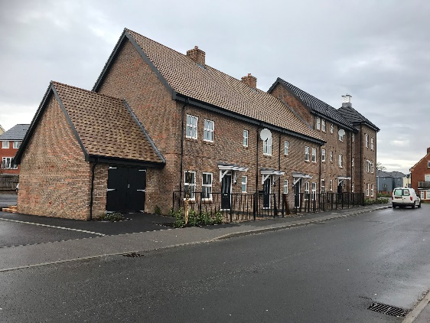

Figure 25 Abbotswood, Romsey

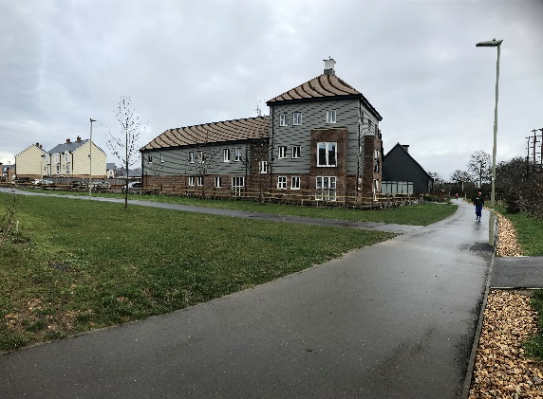

Figure 26 Abbotswood, Romsey

Picket Twenty, Andover - Sage

These flats were delivered with Sage Housing, at Picket Twenty, Andover. There were 17 flats for social rent, 7 x one bedroom and 10 x two bedroom. These homes were completed in February 2021.

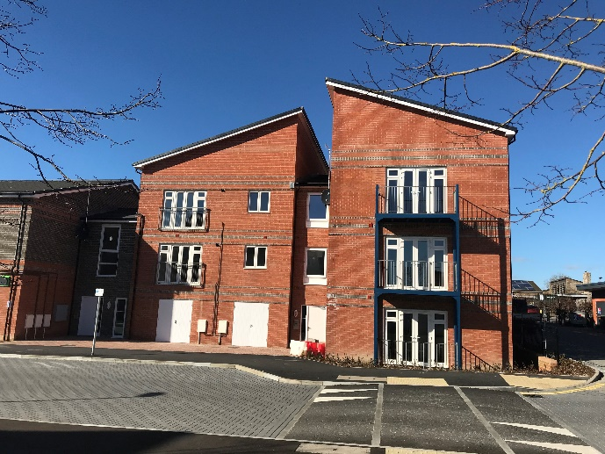

Figure 27 Picket Twenty, Andover

Should you wish to discuss affordable housing delivery in more detail, please contact the

Housing Development Team [HousingDevelopmentTeam@testvalley.gov.uk](mailto:HousingDevelopmentTeam@testvalley.gov.uk)

Last Updated: April 2021

|  |  |
| --- | --- |
| **Winchester City**  **Council**  **Housing Development** | Figure 28Winchester City Council logo |

Winchester City Council is embracing sustainable technologies and renewable energy in its schemes that are in the early stages of development, to contribute to the council’s ambition of making the Winchester District carbon neutral by 2030. The council is very excited to have its first PassivHaus scheme being considered for planning approval and is committed to building to PassivHaus and AECB building standards wherever practicable.

**Completed developments**

Dolphin Hill, Twyford

Two new homes at Dolphin Hill were completed in September 2020. The new residents benefit from energy efficient homes fitted with solar panels and air source heat pumps providing heating and hot water.

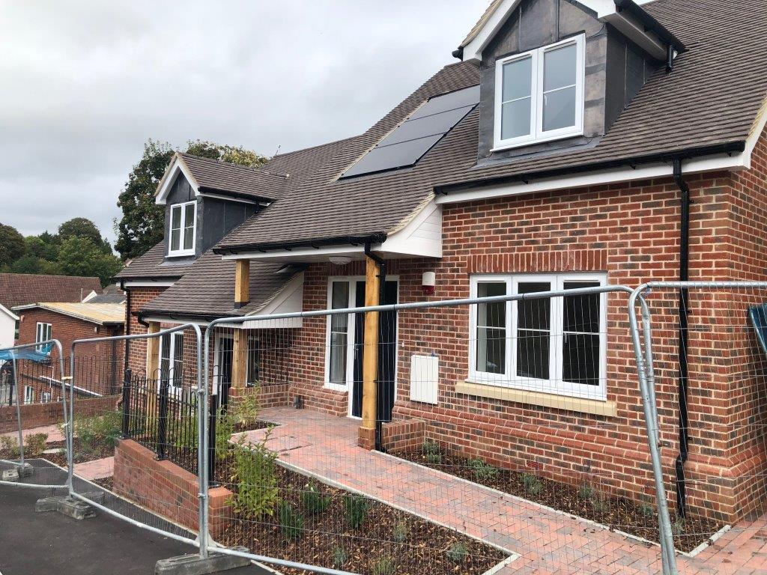

Figure 29 Dolphin Hill, Twyford

The pair of semi-detached houses has improved the street scene and local residents have commented on how good the new homes look.

**Under construction**

The Valley, Winchester

Work is nearly complete at The Valley in Stanmore. Most of the 77 new homes, comprising one, two and three bedroom flats (6 blocks), two and four bedroom houses and a three bedroom bungalow. Phased handovers started in June. The new homes will be a mix of shared ownership and social rented properties. The first phase of the development was due to be completed in early 2021 but the Covid Pandemic delayed this.

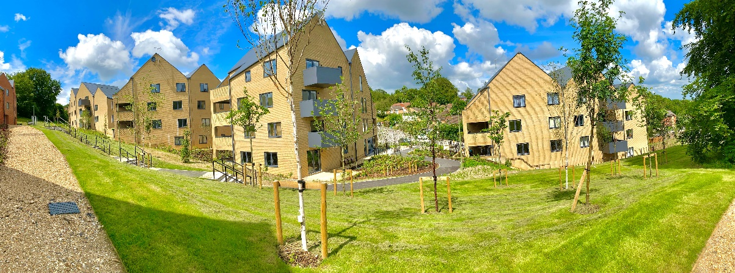

Figure 30 The Valley, Winchester

Hookpit, Kings Worthy

Construction in Kings Worthy to deliver 35 affordable homes is complete. The Council worked with Drew Smith to deliver this scheme and change the remainder of the land from agricultural to publicly accessible recreation land.

The 35 homes will be managed by the Council:

* A mix of 1 and 2 bedroom flats and 2 and 3 bedroom houses for affordable rent
* 2 and 3 bedroom houses will be available for shared ownership
* Two 4 bedroom houses will be sold as discounted market sale homes

The open space will be managed by the Council.

Gates Gardens, Rowlings Road, Winchester

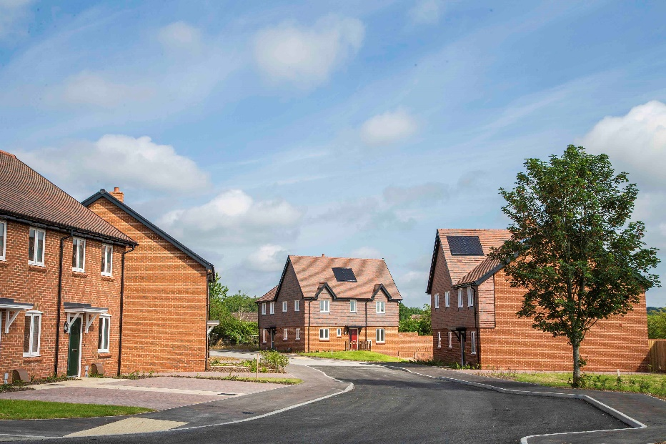

Figure 31 Gates Gardens, Winchester

The Council completed 7 dwellings at Gates Gardens, Rowlings Road, in Winchester in March 2021 on a former disused garage site. The development comprises 3 two bedroom family homes and 4 one bedroom flats.

Along with the development there are associated improvements to public footpath routes.

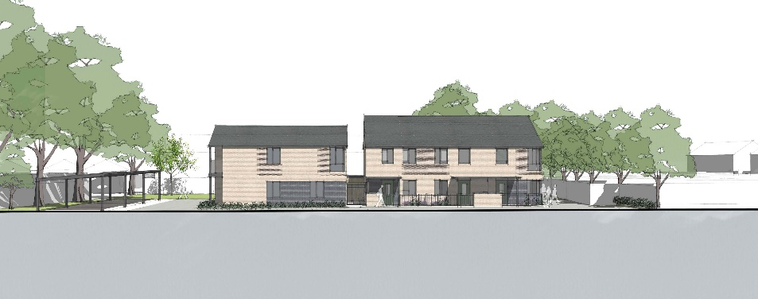

Figure 32 Gates Gardens, Winchester